6B.5 Minimal Power Query steps
v_trip | Conditional column: Distance Band | Short haul / Regional / Long haul / Interstate

Mark as Date Table
- Model view → select v_date.
- Table tools ribbon → Mark as date table.
- Choose the Date column.
- Confirm the green tick appears.

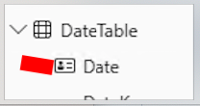

8.3 Service performance measures
On Time % = AVERAGE ( v_consignment_delivery[is_on_time] )

8.8 Time intelligence
On Time % YoY pp = [On Time %] - [On Time % LY]

8.9 KPI measures with targets and status
OTD vs Target pp = [On Time %] - [OTD Target]

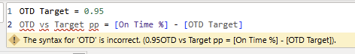

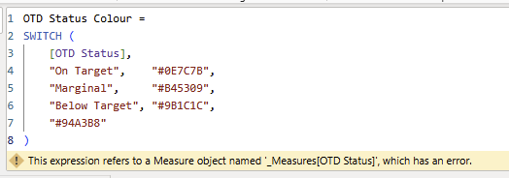

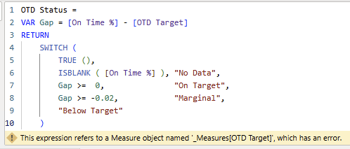

8.10 Dynamic titles and narrative measures
OTD Headline =
VAR Rate = [On Time %]
VAR Gap = [OTD vs Target pp]
VAR Verdict = IF ( Gap >= 0, "above", "below" )
RETURN
"On-time delivery is " & FORMAT ( Rate, "0.0%" ) &
", " & FORMAT ( ABS ( Gap ), "0.0" ) & " points " & Verdict &
" the 95% commitment."

9.2 Report 1 — Network Performance

